General information about the crops
ONION
Season – Kharif Crop

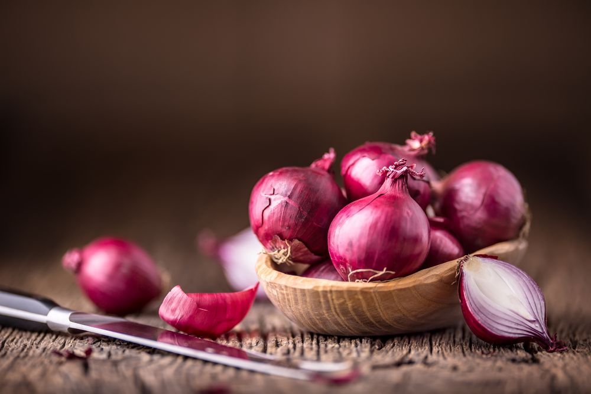

General

- Onion is most widely cultivated popular vegetable species.
- It is used for culinary purpose also it has several non- Culinary use like it is used as Moth repellent because of its pungent juice , it is used to polish glass and copperware , onion concentrates water can be spray on plants to increase plant pest resistance .

- Climate
Temp  (20°C/25°C) | Rainfall  (650 MM/750MM)
Sowing Temperature  (20°C/25°C) | Harvesting Temperature  (40°C/50°C)

- Popular variety with their Yield.
Variety | Yield
Hissar 2 | 120qtl/acre
Pusa Red | 100-120qtl/acre
Hissar Onion - 3 | 125qtl/acre

- Land preparation

- Give three to four deep ploughing and bring soil to fine tilth .
- Add well decomposed cow dung to increase organic content of soil , then levelled the Soil and divide into small plots and channels .

- Sowing

- Sowing or transplanting of seedlings can be carried out in a wide range of weather conditions .
- Direct sowing can also be done .
- Planting bilbs in the fields.

- Seed Rate

- The seed quantity required to raise the seedling for one hectare is about 5-7 kg.

- Seed Treatment
- Treatment with Fungicide , tebuconazole , reduced the incidence of onion smut by 90 to 98%.
- Treatment of thiram or Carboxin for fungus .

- Fertilizer Application

- Apply 40 :20 : 40 kg/acre .
- In high weed infested fields , apply approved herbicides and spray oxyfluorfen 23.5 EC@170-340ml in 200 – 300l of water.

- Weed Control

- Spray Pendimethalin (stomp)@ 1 litre/200 litre water/acre within 72hours of sowing.
- Apply Oxyfluofen@425ml/200ltr of water per acre as Post – Emergence Herbicide 7 days after planting .

- Irrigation

- One irrigation is require just after Transplanting .
- In kharif season , 8 – 10 irrigations are required .
- In rabi season , it require 15 – 20 irrigation .

- Harvesting

- Most dry onions are harvested when one – third to one – half of the tops have fallen over.
- Bulbs are generally pulled from the soil after being loomed with a disk .

- Plant protection
Thrips – I not controlled properly can cause yield loss by 50% .
Management
Spray of Fipronil@ 30ml/15ltr water.
Maggots – Infestation observed in the month of January – Februry .
Management
Apply Carbaryl@1ltr or Phorate@4kg to soil and give light irrigation .

Purple blotch and Stemphylium blight .
It can cause to loss of 70% .
Take spray of propineb 70%WP@350gm/acre.

- Storage
Store onions in a cool, dry, well-ventilated area. Maintain storage temperature of 45-55°F. Do not wrap onions in plastic or store in plastic bags. A lack of air circulation will reduce shelf life.

